Command-Line Banking System
Course Name: BTech CSE IoT
Student Name: Soumyadeep Das
Roll Number: 51
Instructor Name: Soumadip Biswas
Problem Statement
The objective of this project is to design and implement a Command-Line Banking System in Java that demonstrates core Object-Oriented Programming (OOP) principles.
The system allows users to perform basic banking operations such as:
- Account creation
- Deposit and withdrawal
- Fund transfer
- Balance inquiry
- Transaction history
The application simulates a simplified banking environment using a terminal-based interface. It ensures proper input validation and error handling for scenarios such as insufficient balance and invalid account numbers.
The project focuses on clean design, modular structure, and the use of OOP concepts like abstraction, inheritance, polymorphism, and exception handling.
System Design
Major Classes
- Account (Abstract Class) → Base structure for all accounts
- SavingsAccount & CurrentAccount → Different account types
- Customer → Holds account + transaction history
- Transaction → Stores transaction details
- Bank → Handles all operations
- BankException → Custom error handling
- Main → User interface
Interaction Flow
User → Main → Bank → Customer → Account → Transaction
Package Structure
All classes are kept in a single directory without packages to simplify execution and understanding.
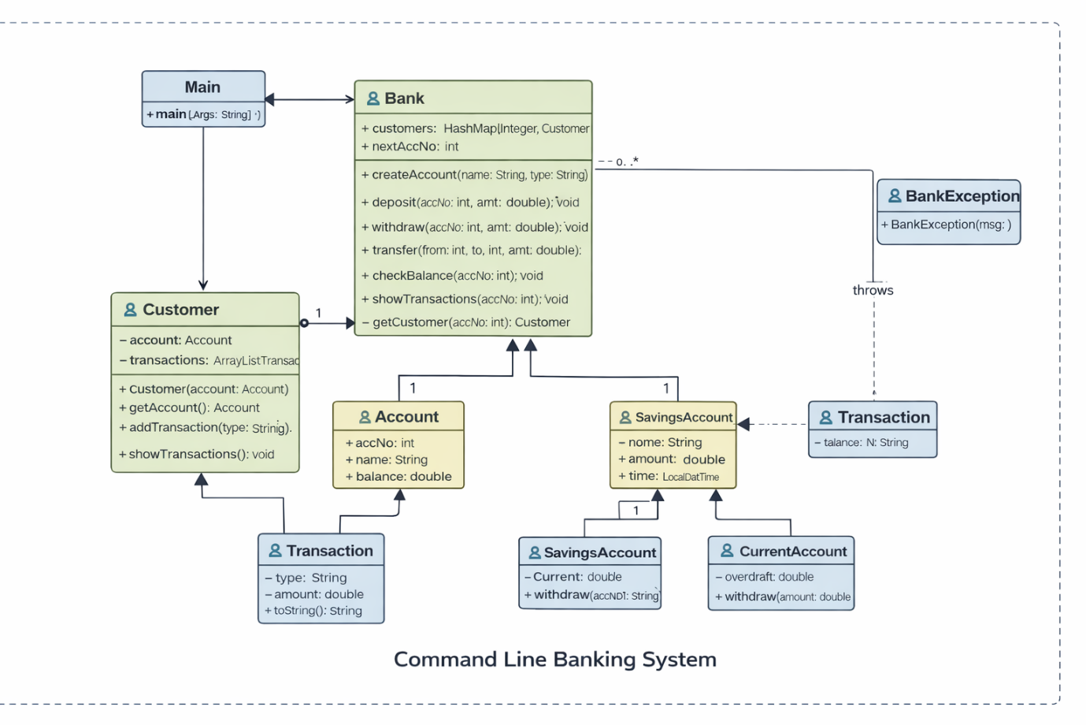OOP Concepts Demonstrated
1. Abstraction
Where used:
Account class
Why:
To define common structure and hide implementation details
Code Snippet:
public abstract class Account {
protected double balance;

public void deposit(double amount) {
balance += amount;
}

public abstract void withdraw(double amount);
}
Explanation:
The abstract class defines common methods and forces subclasses to implement withdraw().
2. Inheritance
Where used:
SavingsAccount and CurrentAccount
Why:
To reuse code and extend functionality
Code Snippet:
public class SavingsAccount extends Account {
public SavingsAccount(int accNo, String name) {
super(accNo, name);
}
}
Explanation:
SavingsAccount inherits properties like balance and methods like deposit.
3. Polymorphism
Where used:
withdraw() method
Why:
Different behavior for different account types
Code Snippet:
@Override
public void withdraw(double amount) {
if (amount > balance) {
throw new BankException("Insufficient Balance!");
}
balance -= amount;
}
Explanation:
Same method behaves differently depending on account type.
4. Exception Handling
Where used:
BankException
Why:
To handle errors properly
Code Snippet:
public class BankException extends RuntimeException {
public BankException(String msg) {
super(msg);
}
}
Explanation:
Custom exception handles errors like invalid operations.
Implementation Highlights
1. Account Creation
public void createAccount(String name, String type) {
Account acc;

if (type.equalsIgnoreCase("savings")) {
acc = new SavingsAccount(nextAccNo, name);
} else {
acc = new CurrentAccount(nextAccNo, name);
}

customers.put(nextAccNo, new Customer(acc));
}
Creates different account types using inheritance.
2. Deposit Operation
public void deposit(int accNo, double amt) {
Customer c = getCustomer(accNo);
c.getAccount().deposit(amt);
}
Uses abstraction via Account class.
3. Fund Transfer
public void transfer(int from, int to, double amt) {
withdraw(from, amt);
deposit(to, amt);
}
Reuses existing methods → clean design.
4. Transaction Recording
public void addTransaction(String type, double amt) {
transactions.add(new Transaction(type, amt));
}
Stores transaction history.
Testing & Error Handling
Test Cases
- Valid deposit
- Valid withdrawal
- Fund transfer
- Transaction history
Edge Cases
- Insufficient balance
- Invalid account number
- Negative amount
Failure Handling
try {
bank.withdraw(accNo, amt);
} catch (Exception e) {
System.out.println("Error: " + e.getMessage());
}
Prevents program crash.
Git Workflow
Steps Followed
- Initial project setup
- Added account features
- Added transaction system
- Added exception handling
Conclusion & Future Scope
Conclusion
The project successfully demonstrates:
- Object-Oriented Programming
- Modular design
- Error handling
It simulates a basic banking system effectively.
Future Scope
- GUI using Java Swing
- Database integration
- User authentication system

